

**INTRODUCTION:**

Per our in-class instructions, our group has put together a job search platform for the association DCDR.sa that allows employees and non-employees alike to browse through job postings and apply to qualifying positions. Our project was put together using HTML, CSS, and PHP which we hosted on a local server using WAMP. Our database was constructed using WAMP’s built-in MariaDB. All in all, we have a cohesive site that is successfully connected to the database, friendly to its users, and performs the majority of the capabilities requested. We also wrote the majority of the code ourselves and didn’t pull from pre-existing frameworks.

Especially having a group with most members being new to this type of project we had a lot of learning to do. Most of us were not familiar with WAMP or PHP but we made up for this by keeping up consistent effort, meeting regularly, and trying our best to keep organized. I think these strengths as well as everyone’s willingness to step up and do the work allowed us to achieve the success that we did. Hope you enjoy it!

**ARCHITECTURE:**

This is a user centered architecture for our system and gives an overview of how we broke it down accordingly.

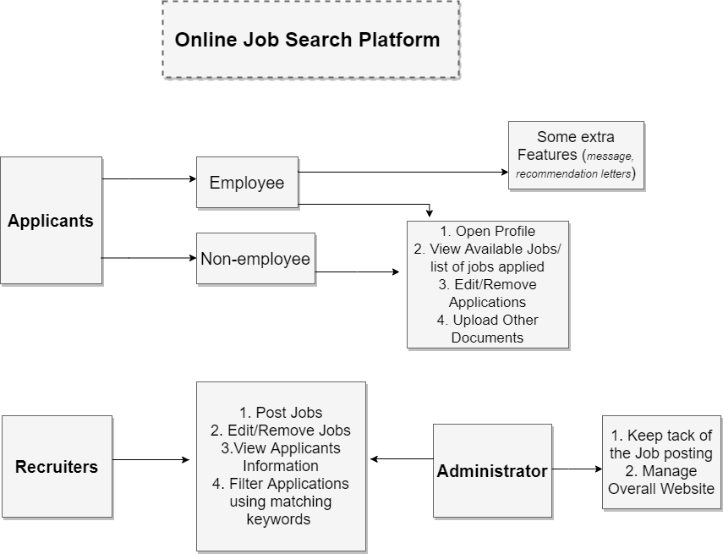

**PROJECT BACKLOG:**

*User Requirements:*

* Permits Applicant (Employee and Non-employee) to-
  + Create a profile with important information (i.e. personal information and areas of interest).
  + Submit resume and other documents.
  + Subscribe email notification about latest positions and possible matches
* Matches identified using textual analysis among the job descriptions, areas of interest.
* Filter according to number of positions available, salary, state/region, qualifications.
* Receive job suggestions of other jobs that match with an applied one.
* Have a page where applicants can see their list of applications.
* Shows status of applications.
* Withdraw or discard their application.
* Edit application information until the due date.

*Employee Applicants can:*

* Request recommendations letter from supervisor
* Access system with job identification number.

*Allows System Administrator to:*

* Keep track of Available positions
* Keep track of Active applications
* Prioritize applications of current/former employees
* Update the status of applications (accepted/denied/finished/in progress)
* Jobs that are filled should be taken off the list of open positions
* Present all jobs according to most relevant and newer positions
* Differentiate between employee and non-employee

*Authorize Recruiters to:*

* Filter suitable applicants by matching key words (education level, experience level, etc.) from resumes uploaded to the system.
* View application details (such as, the number of applications in each job position.).
* Send reminders about upcoming interviews.
* Keep it “organized” by showing a list of “outstanding” candidates and the status of their application.
* Add, remove and Edit job information.

*System requirements:*

|  |  |
| --- | --- |
| * Online * Includes a database that keeps track of all applicants and open positions * Information about internal and external applications * Verifies that applicants only apply to job once * Applications cannot be overwritten * No applications accepted after due date * System can only accept 100 applications per job * Some positions are only for current employees * Applicants can apply to max of 50 jobs at a time * Must go in and remove themselves from closed positions | * Once job is filled   + send an email notification to all applicants   + Change to “FILLED’ * Generates a monthly report including-   + List of current employees applying to open positions   + Percentage of current employee that got a new job   + List of non-employees applying to open positions   + Percentage of non-employee that got a new job   + Area/field receiving the highest number of applications   + Filled position with the highest number of applications |

**DATABASE DIAGRAMS:**

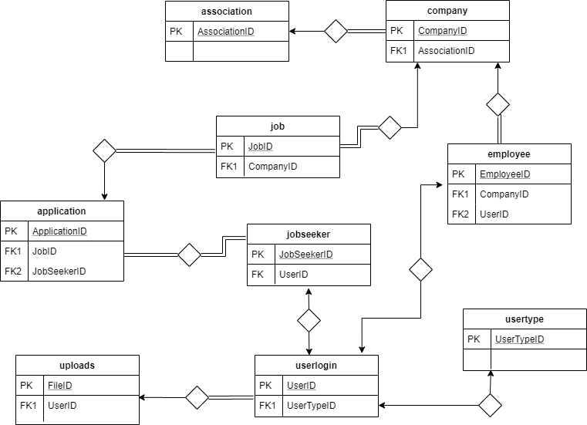

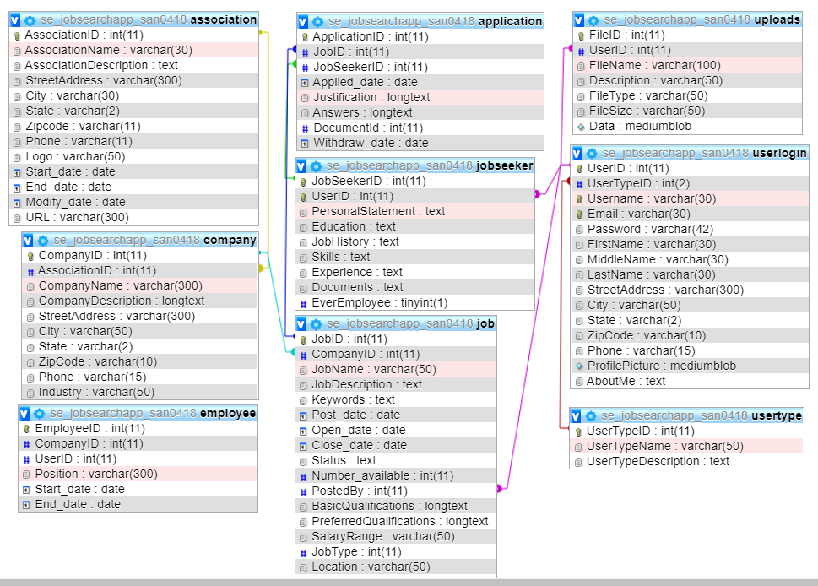

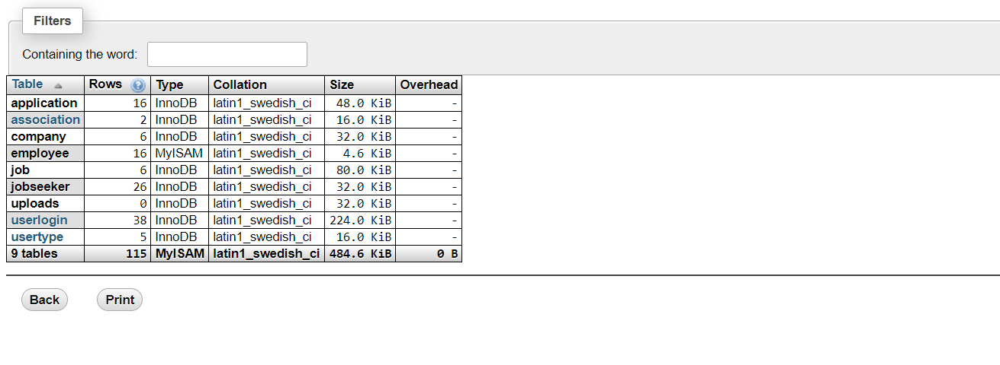

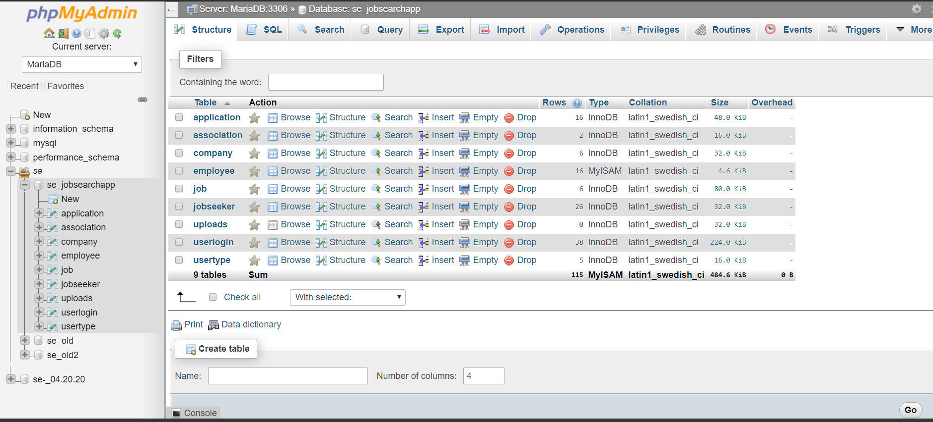

**DATABASE DETAILS:**

Our database is made using MariaDB and managed with WAMP’s phpMyAdmin. In total we have 9 separate tables within our database and many of them contain overlapping data. We had a much simpler design when we created our initial ER Diagram but soon realized this type of set up was necessary in order to keep track of applicants, recruiters, job postings, and applications. This is where a lot of the overlap is created because they have such close relationships, often sharing primary and foreign keys. Overall, we were careful to use what we felt were clear names for the tables and their variables as it was easy to get our labels confused or have them be too similar. (ie. If we had an application table and an applicant table) We were also able to import Danissa’s dummy data as well as create our own data.

We have also included a detailed data dictionary pdf in our submission for more clarity.

**IMPLEMENTATION/TECHNOLOGY:**

Our project was implemented using the recommended format of HTML, CSS, and PHP. We also used WAMP to host our site and the built-in phpMyAdmin to work on our MariaDB database. If you are familiar with WAMP, to run our project you would simply create a new VirtualHost using the contents of our “Group_B_7135-master” folder. This folder contains all of our HTML pages, PHP files, CSS, and database. No need to add, delete, or rename anything. Simply copy and paste it into wamp64’s “www” folder and create a VirtualHost as you usually would. Once this folder has been used to create a VirtualHost and your DNS connections have been presented in order to load the new host you’ll have to import the database. We used WAMP’s built-in phpMyAdmin to do so and our database uses MariaDB. Click on phpMyAdmin under “Tools” or “Your Aliases” and a login page will appear. You can simply type in “root” for the username with no password and be sure you’re opening the MariaDB branch. Next, create a new database called “se_jobsearchapp” and import the SQL file titled “se_jobsearchapp” located in “Group_B_7135-master”. From there you should be able to go to “localhost” in your browser (we mostly used Chrome), click on the VirtualHost you’ve created, and access the project as any intended user would.

If you’re not as familiar with WAMP this is a link with detailed instructions on how to install WAMP, create a VirtualHost, and then import a database.

<https://www.c-sharpcorner.com/article/working-with-wampserver/>

**All of our files are being submitted to moodle but just in case here are our online links**

**Github Link: (Use the Master Branch)**

<https://github.com/SupahWeelz/Group_B_7135>

**Google Drive Folder:**

<https://drive.google.com/open?id=1zTrzyF3xhsc6-Qon7HIJw-lribQwGrSZ>

**ASSUMPTIONS:**

* *Should the administrative report be company specific or whole of DCDR.sa?*
  + *Who is getting the report?*
  + *How often is the report generated and sent?*
* When addressing these questions, we decided that the report would not be company specific as we simply didn’t have enough company specific data for this but in future implementations, we could easily include company specific data in addition to the overall association’s numbers. We also decided that this type of information should be accessible to all recruiter users but left the report dates flexible. The user can actually input the desired dates for their data.
* *Request recommendations letter from supervisor*
* *Organize Interviews*
* Because our system is not actually online, we weren’t able to test and implement email capabilities. Instead, we created a built-in messaging system. This system allows users to interact with each other and they could then request recommendation letters or organize their interview times.
* *Access system with job identification number*
* We assumed that a job identification number was something each company would assign their employees but might not be uniform across the entire association, so we simply allowed job seeker users to create their own username and then our system assigned them a unique ID. We also felt that it was inappropriate for recruiter users to create their own profiles at will so these profiles can only be created by the system administrator directly through the database.

**INTERFACE:**

This is the Home Page that is displayed when you first access the site.

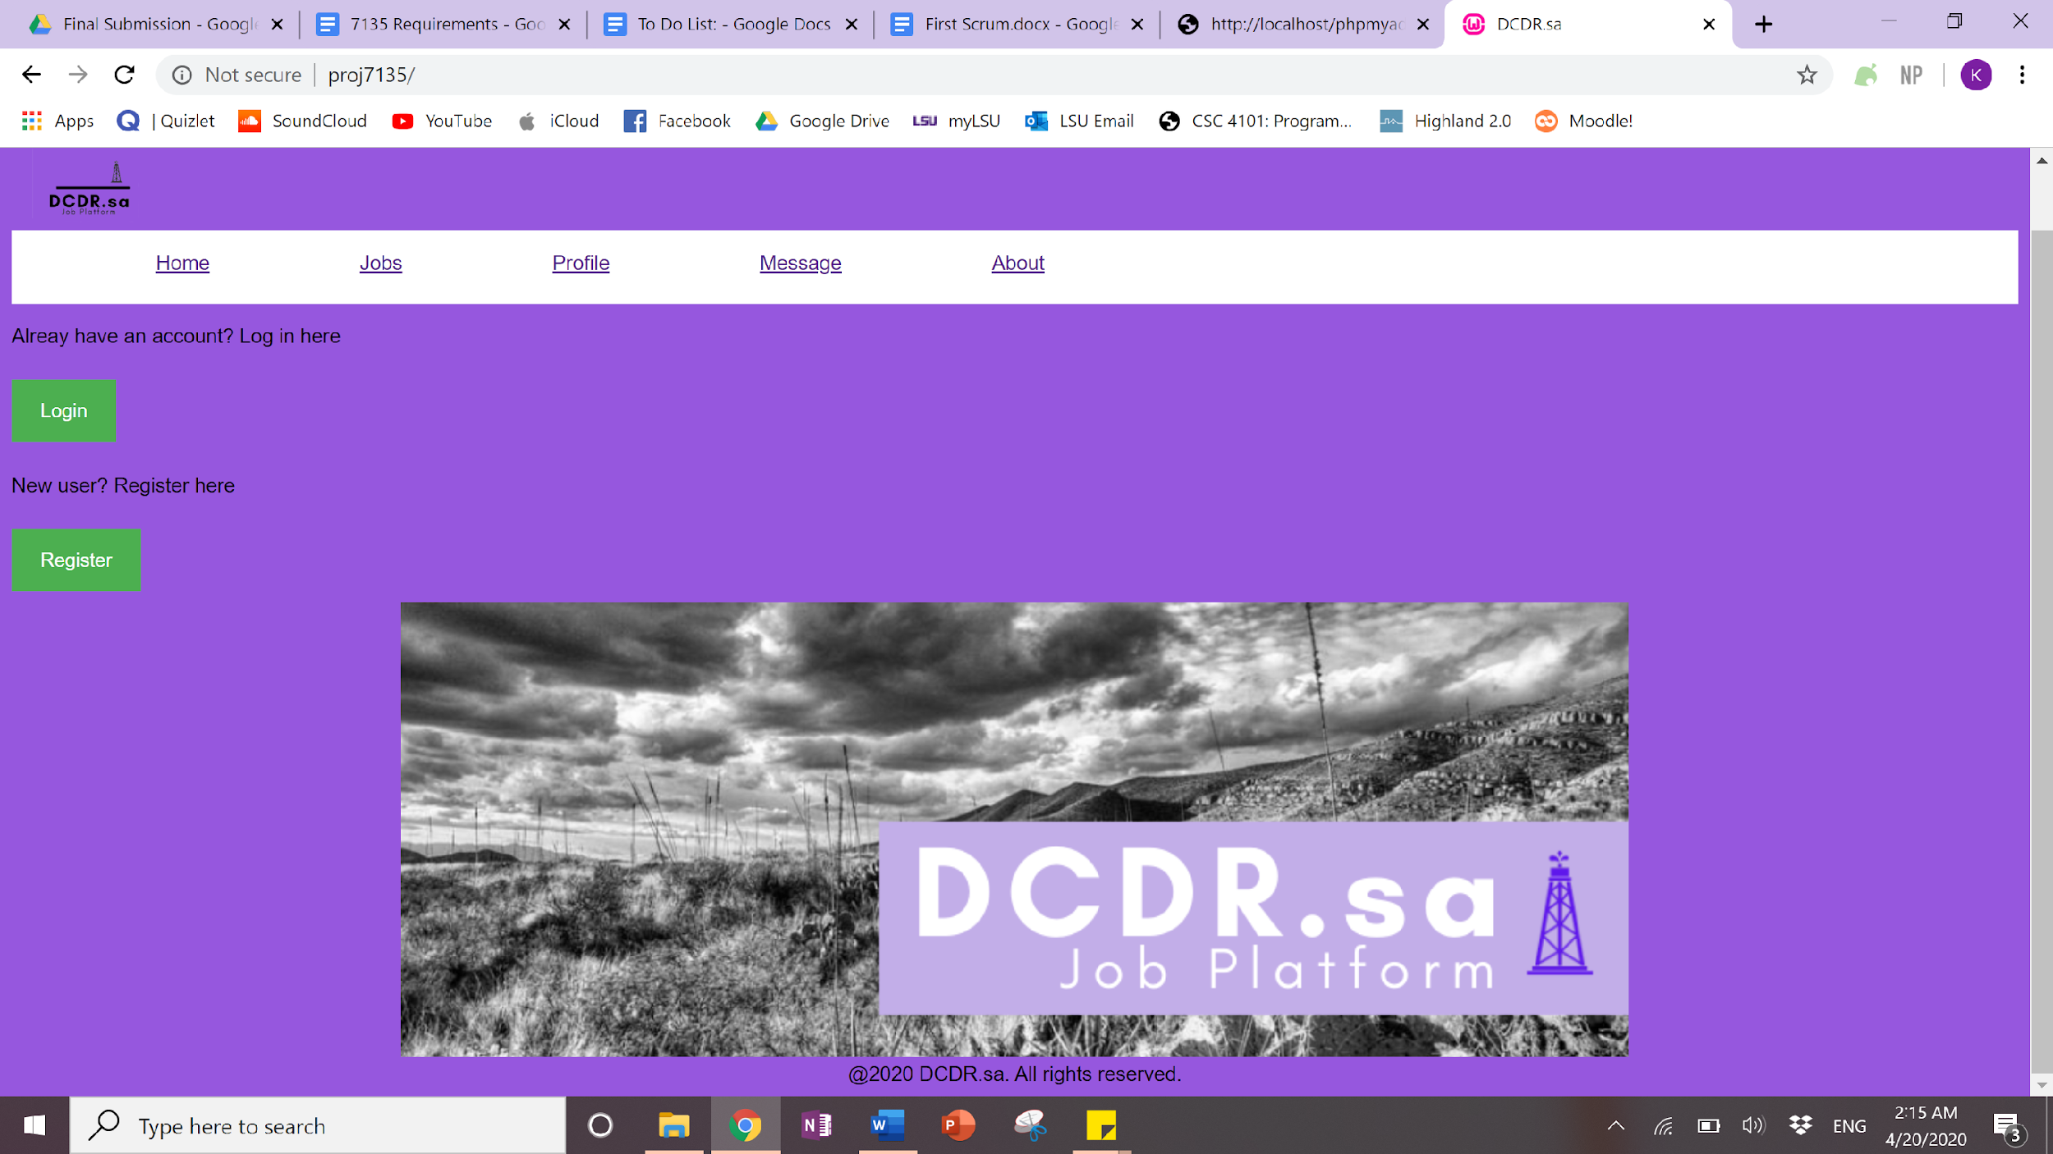

Clicking the “Register Button” will bring you to this page in order to create a job seeker user. Once you’ve registered it will bring you back to the home page where you can now login.

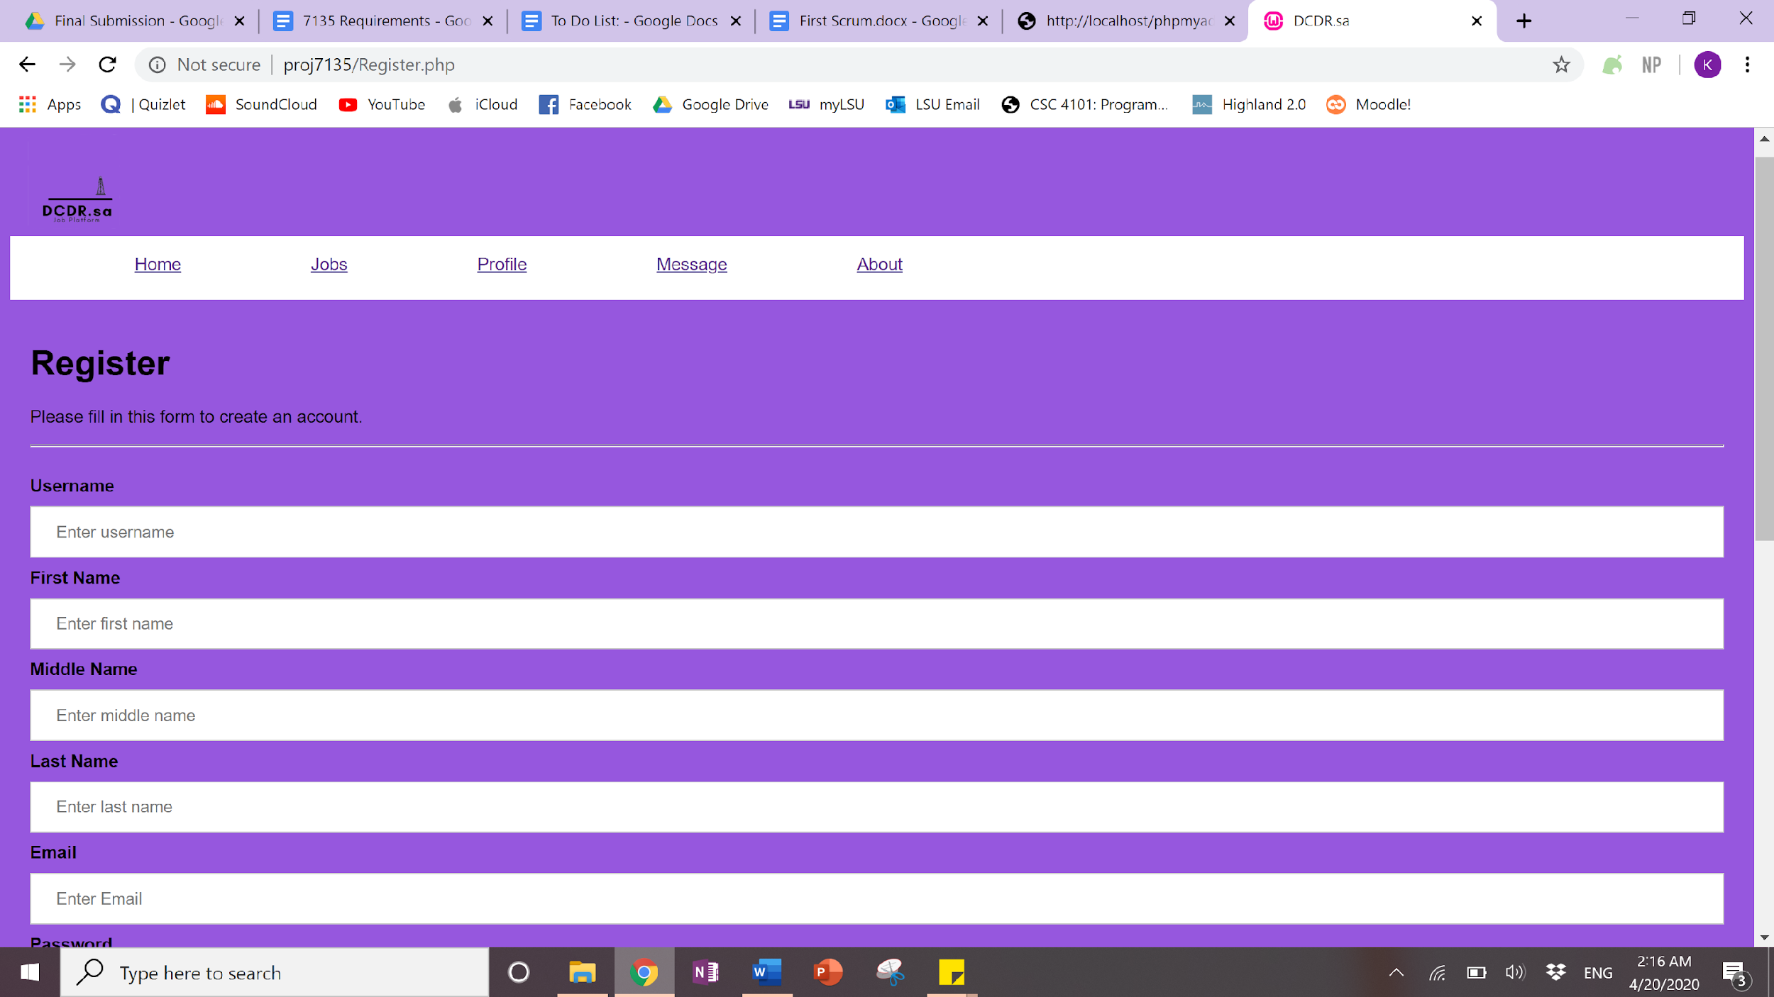

After clicking the Login button on the Home Page a popup prompting you to enter your credentials will show.

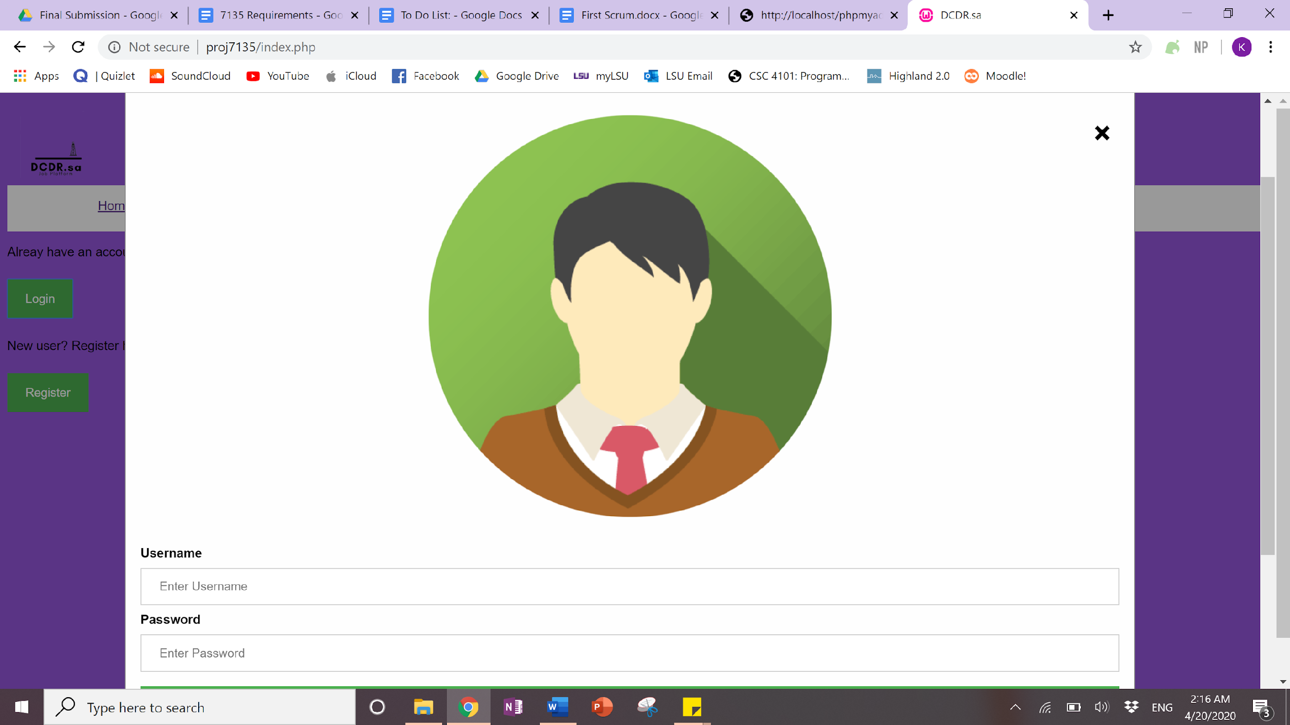

Once you enter valid credentials it will take you back to what looks like the home page but now it only displays “logout”.

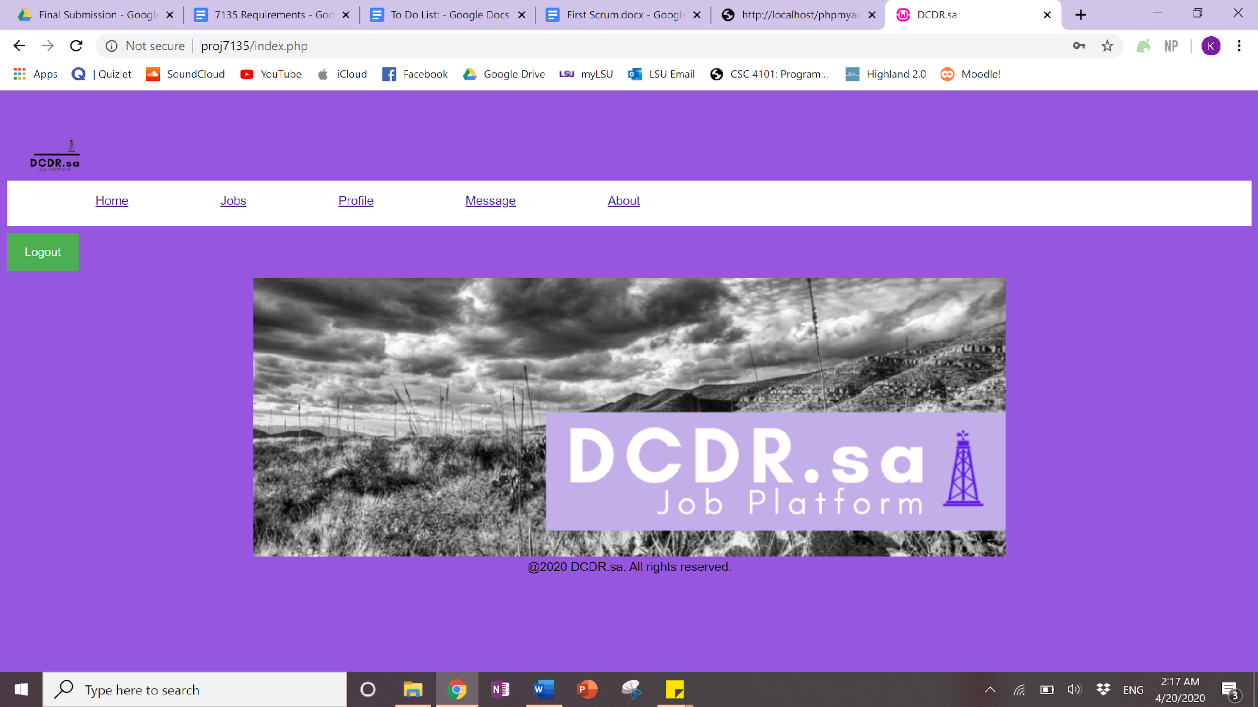

From here if you click the “Jobs” tab on the navigation bar you can now search the database.

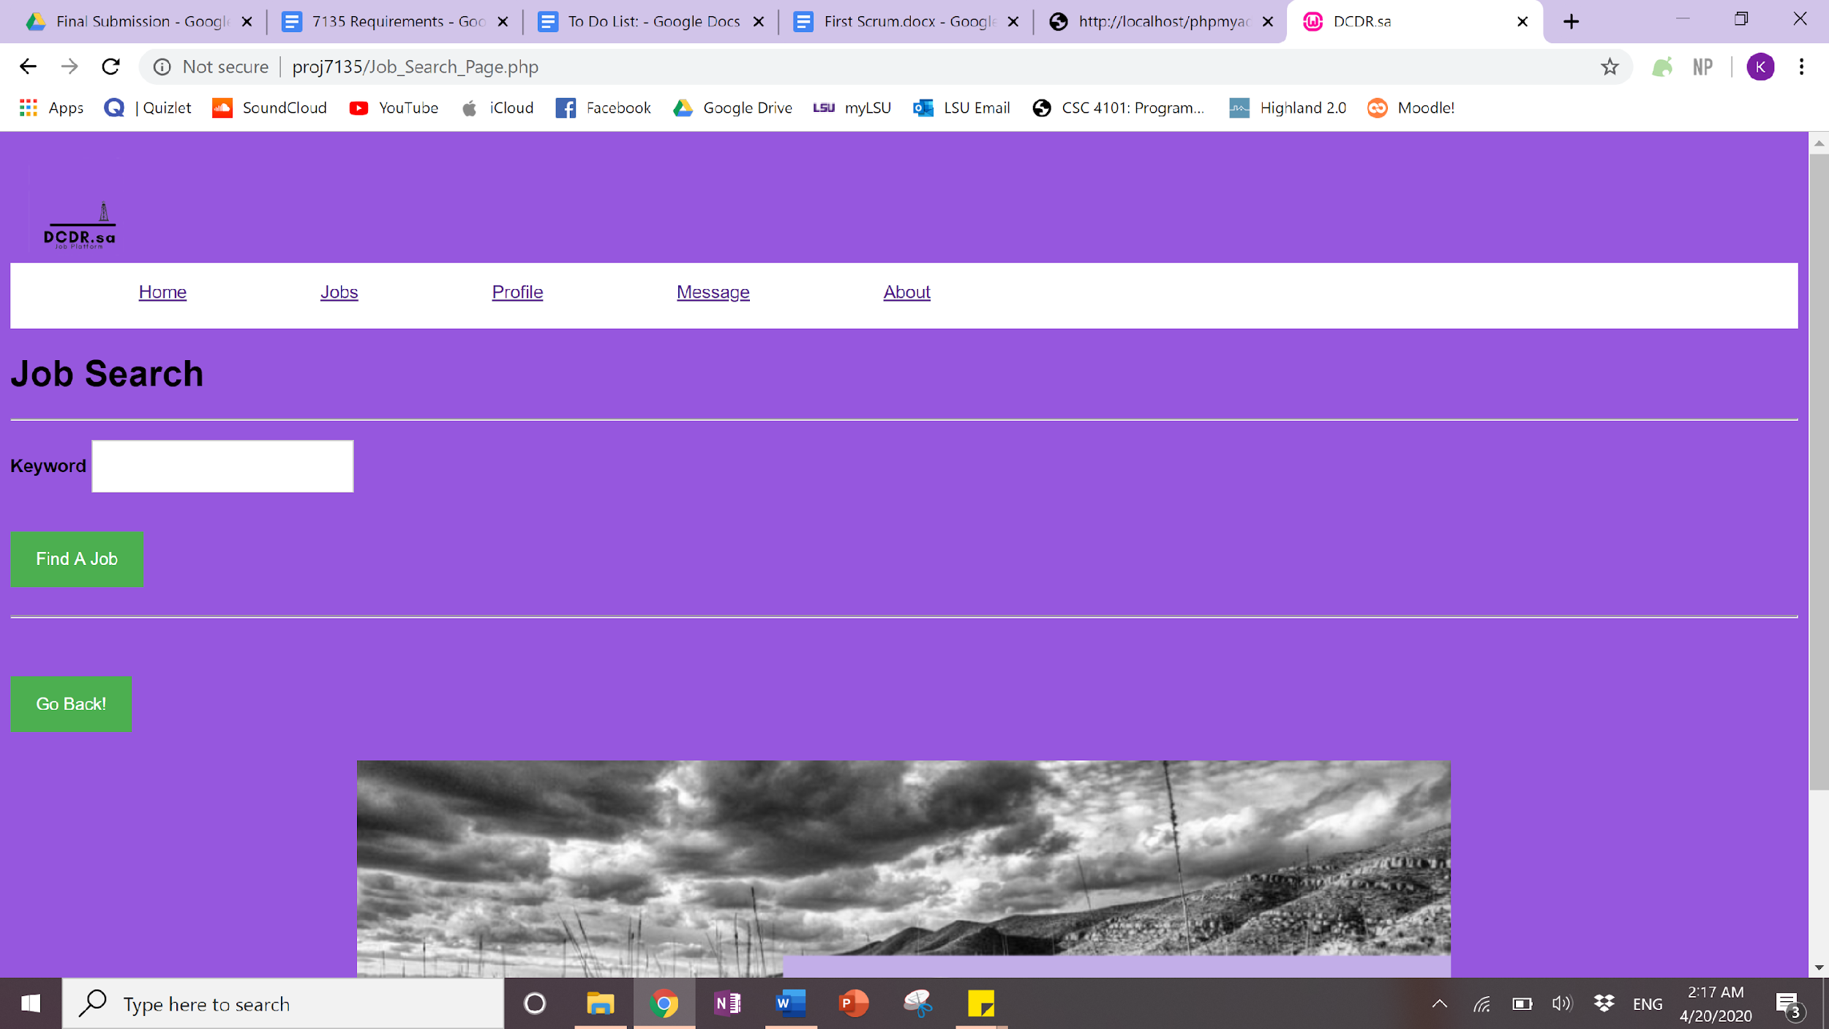

Here I have searched “Engineer” and this is the results page.

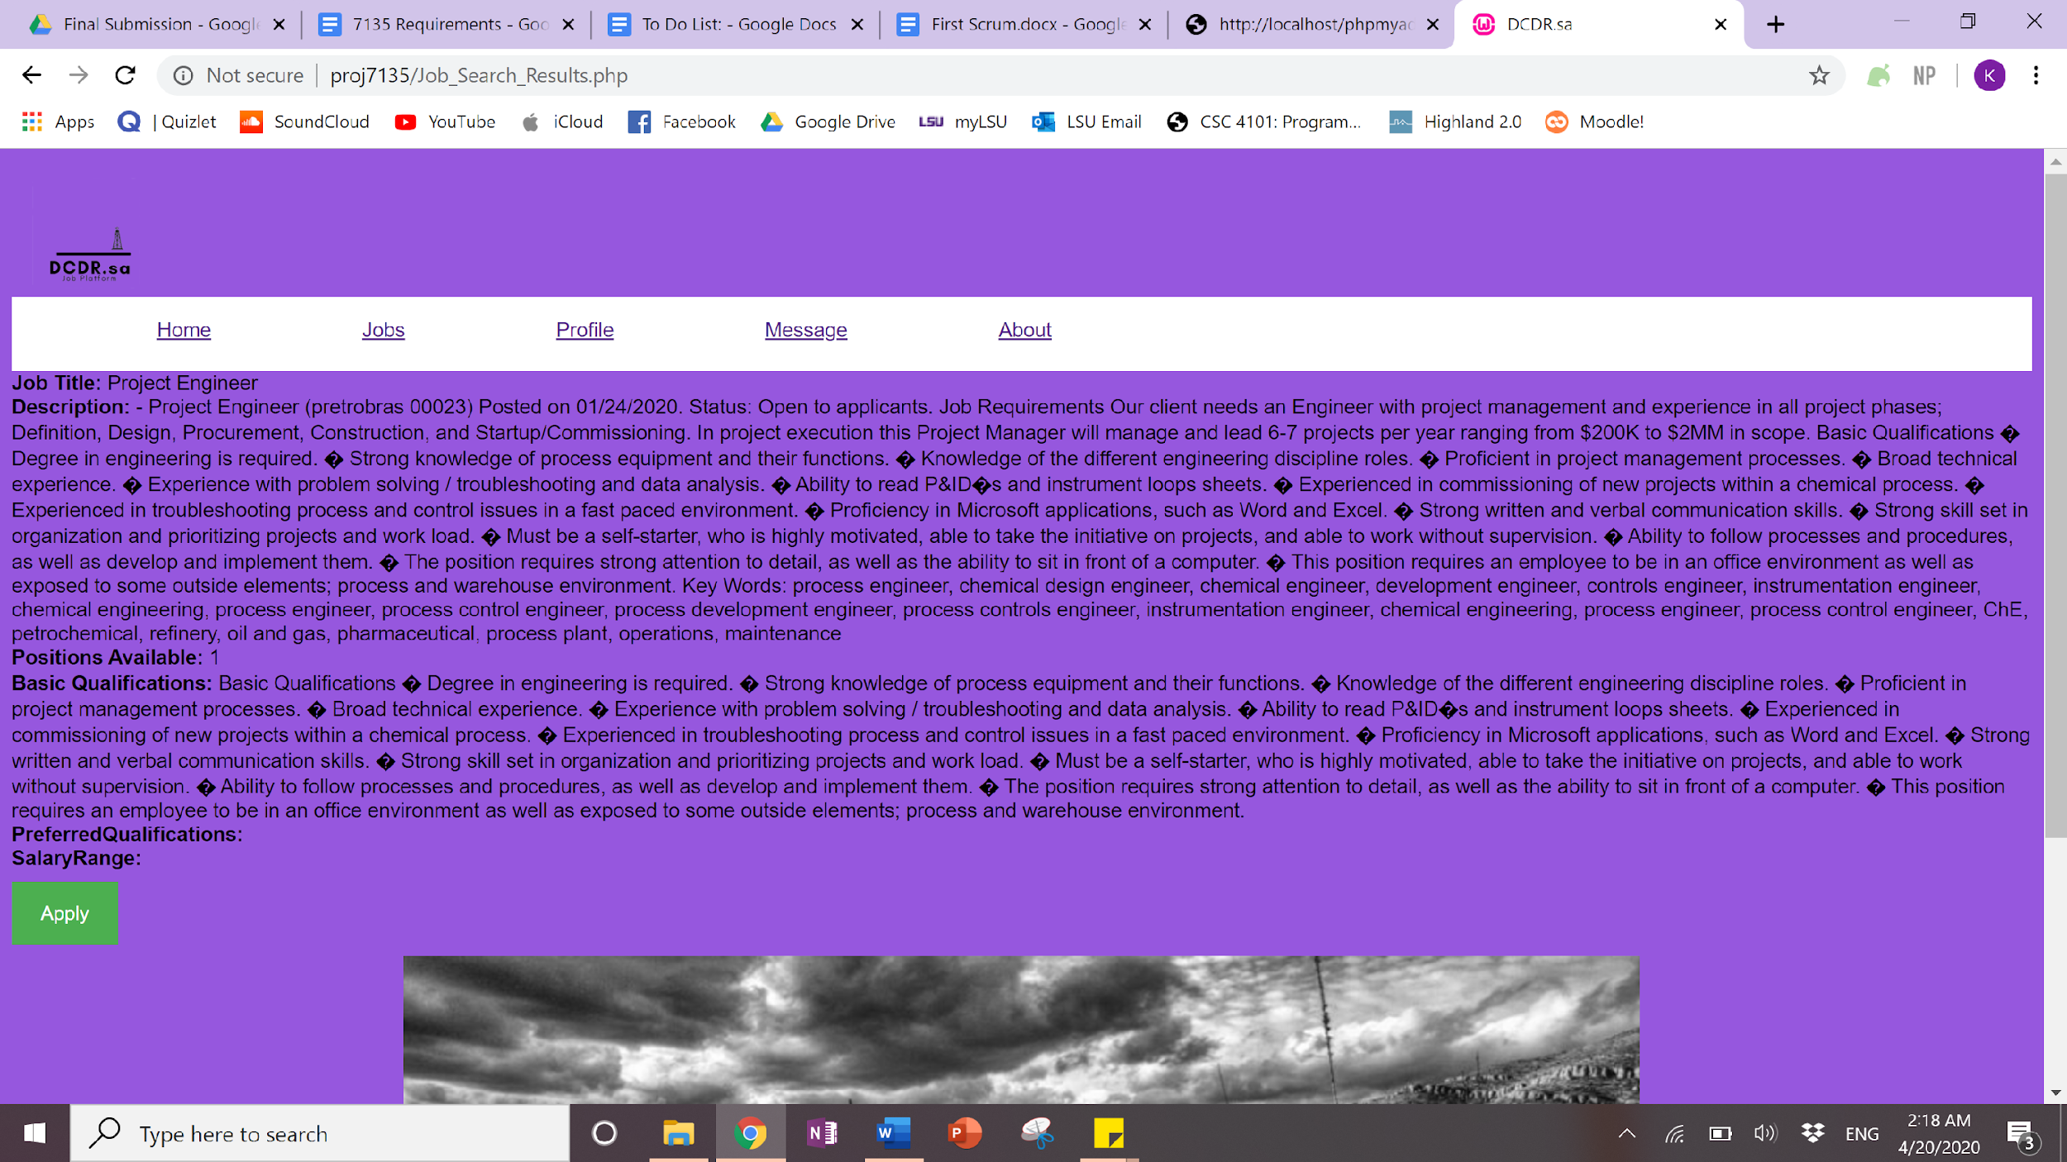

After clicking “Apply” it will then check if you have previously applied.

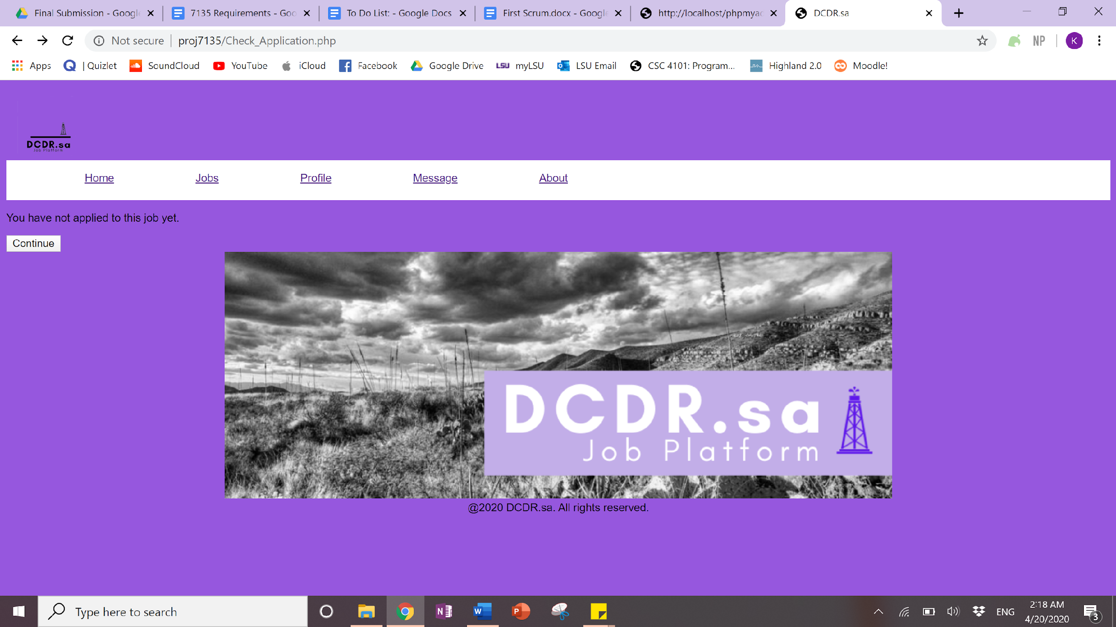

From there it will prompt the user for qualifications for this specific position..

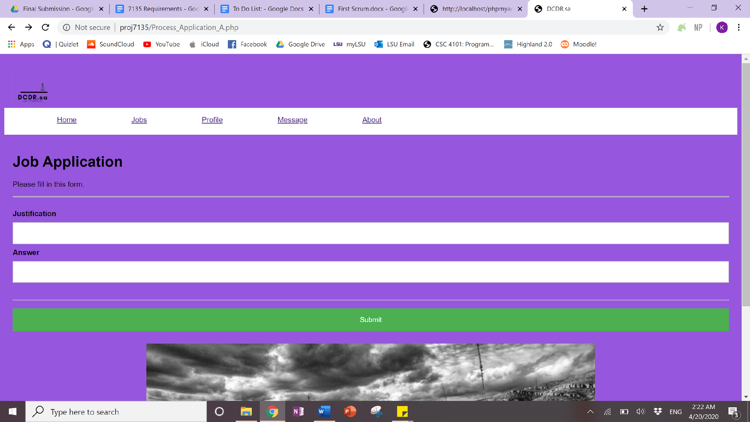

Since this is a new user it prompts the user to finish their registration by manually inputting their information as well as upload any appropriate documents. You can also see it allows them to say if they were ever employed by one of the companies.

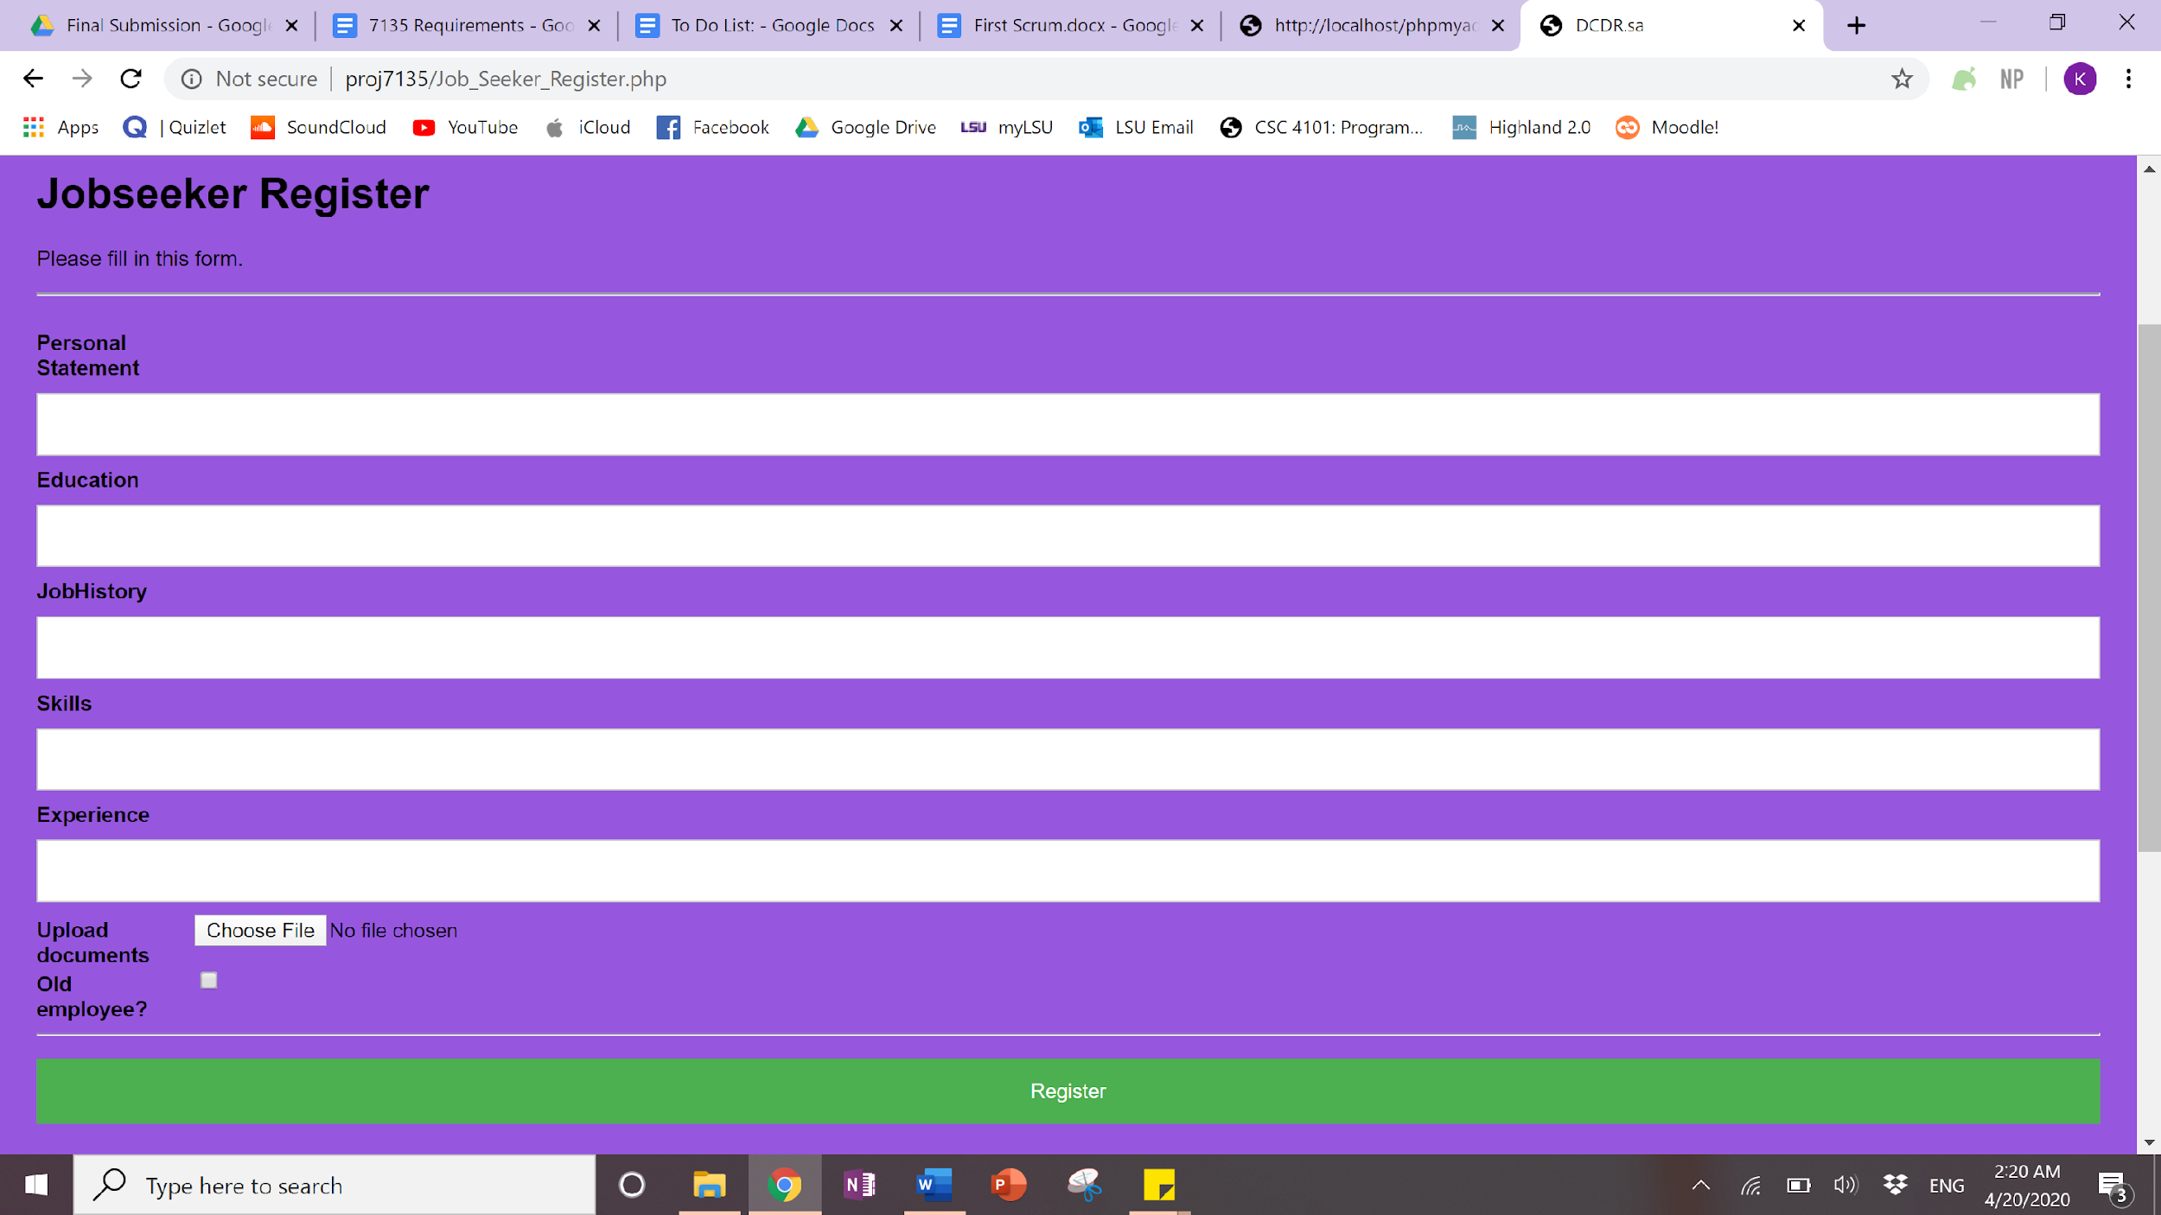

Once you’ve hit the register button it will take you to your profile page. Since it was the first time registering the application is not actually completed and must be done again for it to be accepted in the database. There are several things you can do on the profile page. It is possible to upload a personal profile picture, add an “about me” or bio and continue to search the database.

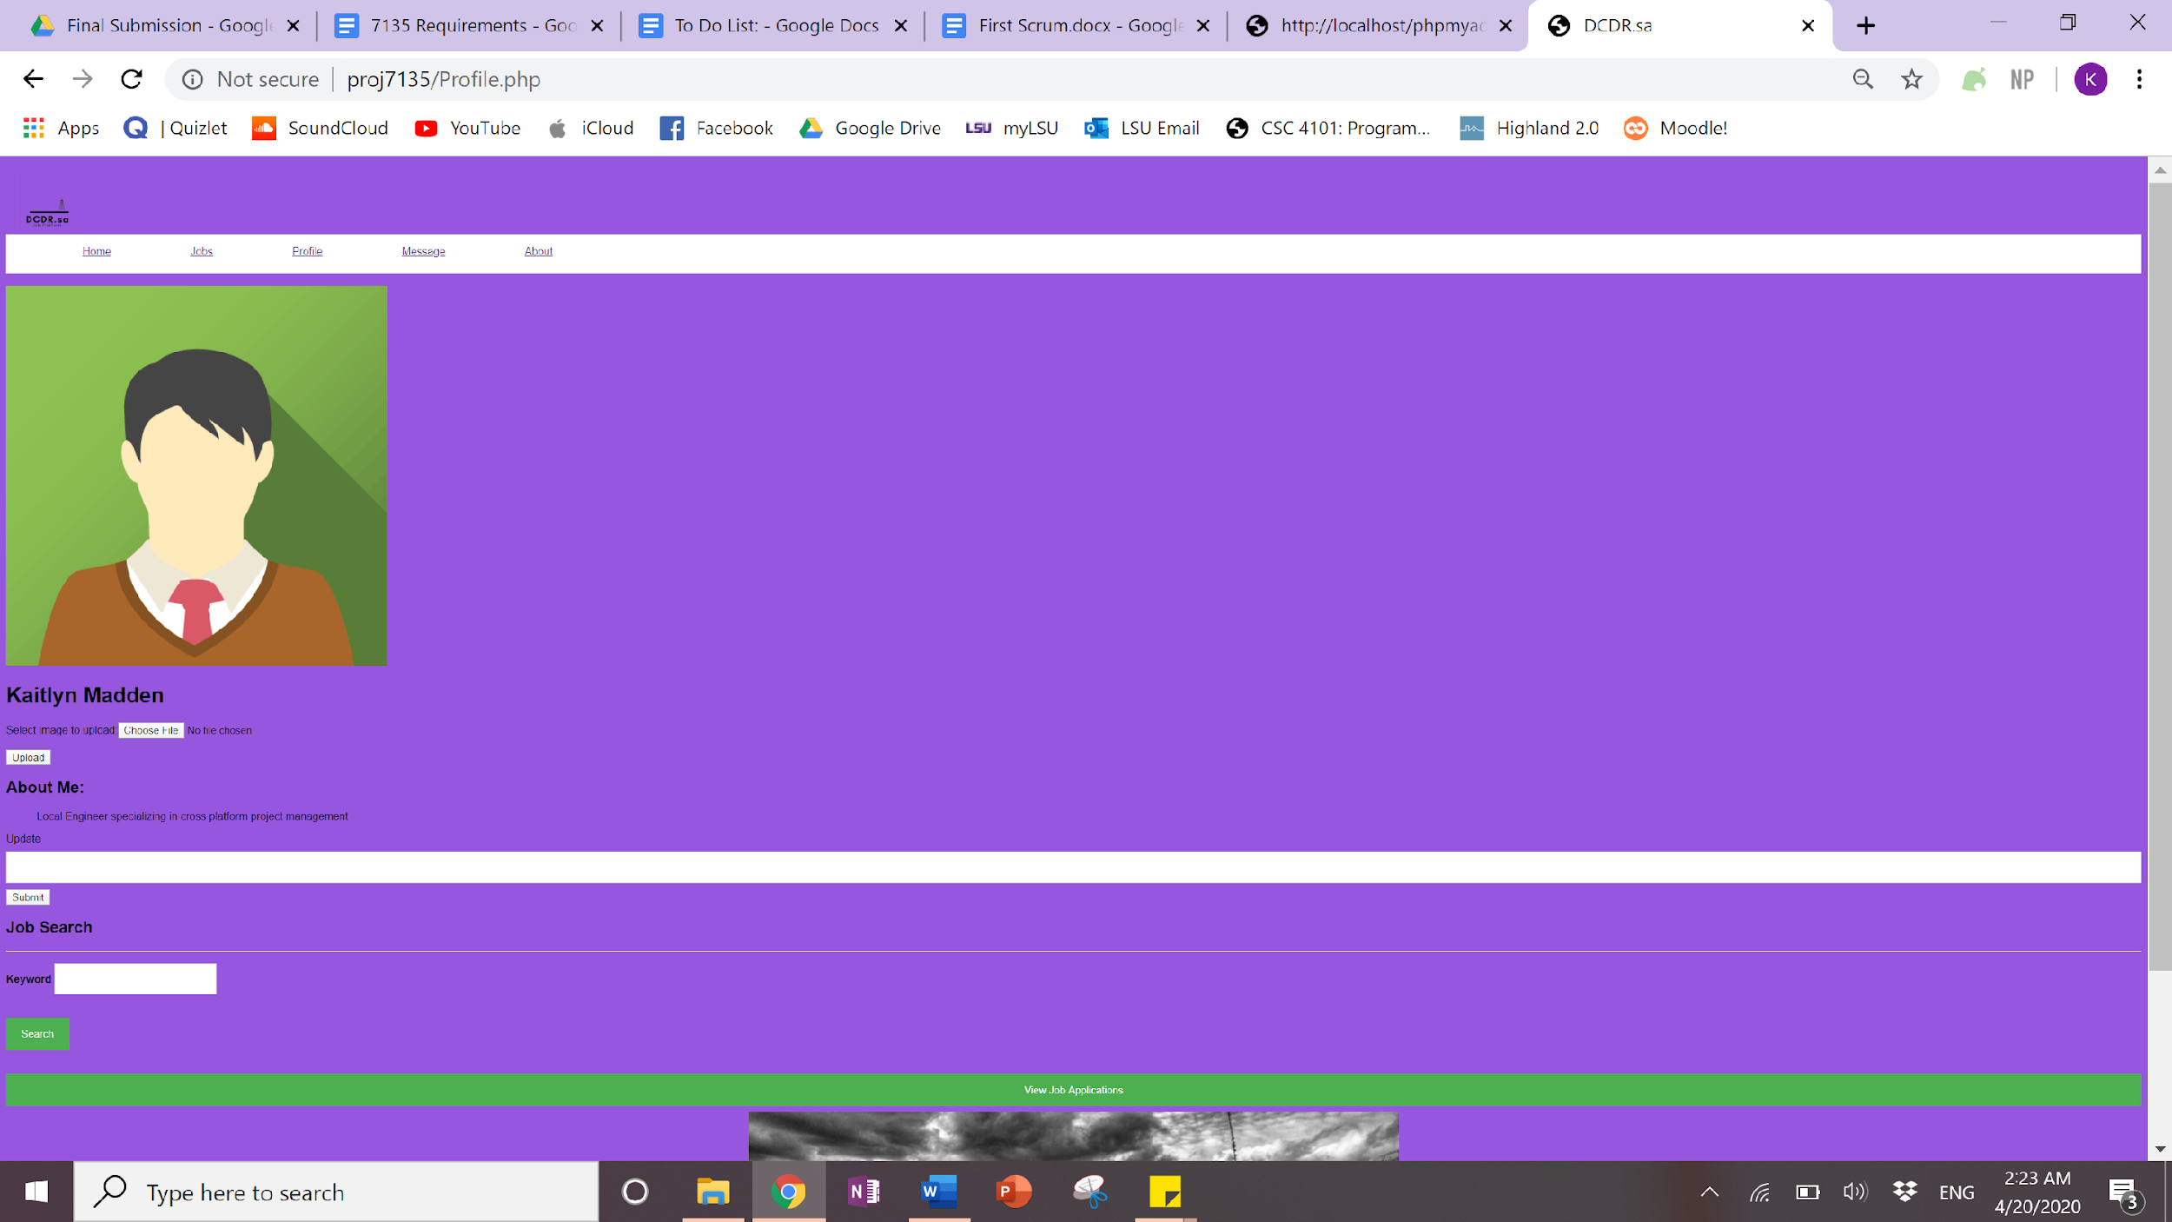

If you click the “View Job Application” button at the bottom it will display any active applications you have and allow you to withdraw your application.

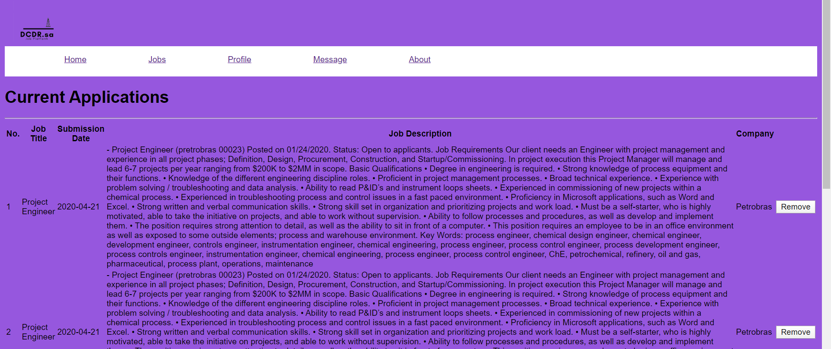

Recruiters also have the option to create new job postings, view their current job postings, and see the ‘monthly’ report.

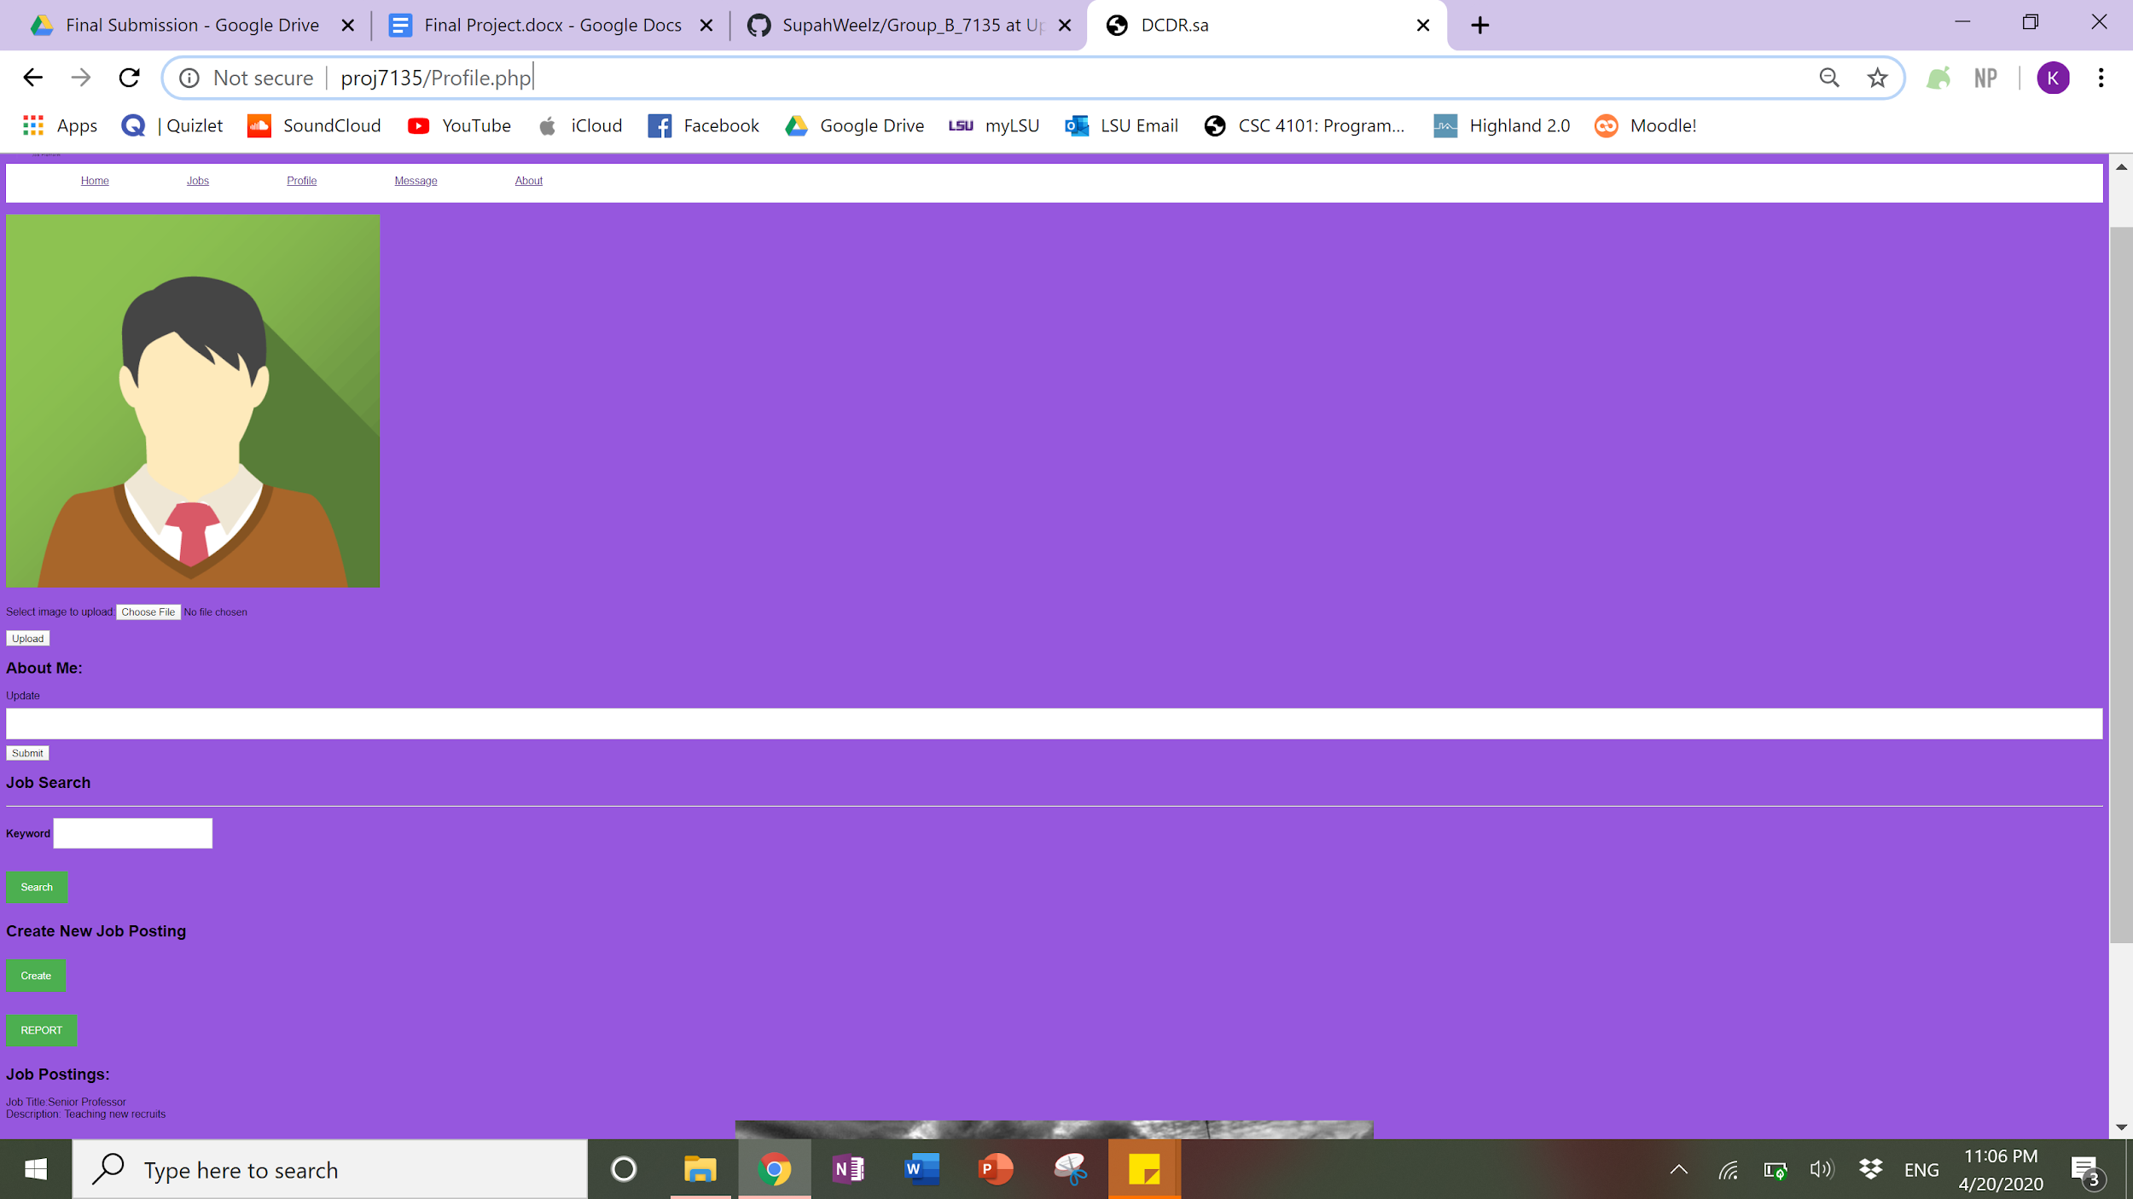

This is the job creation page that is presented after clicking the create button.

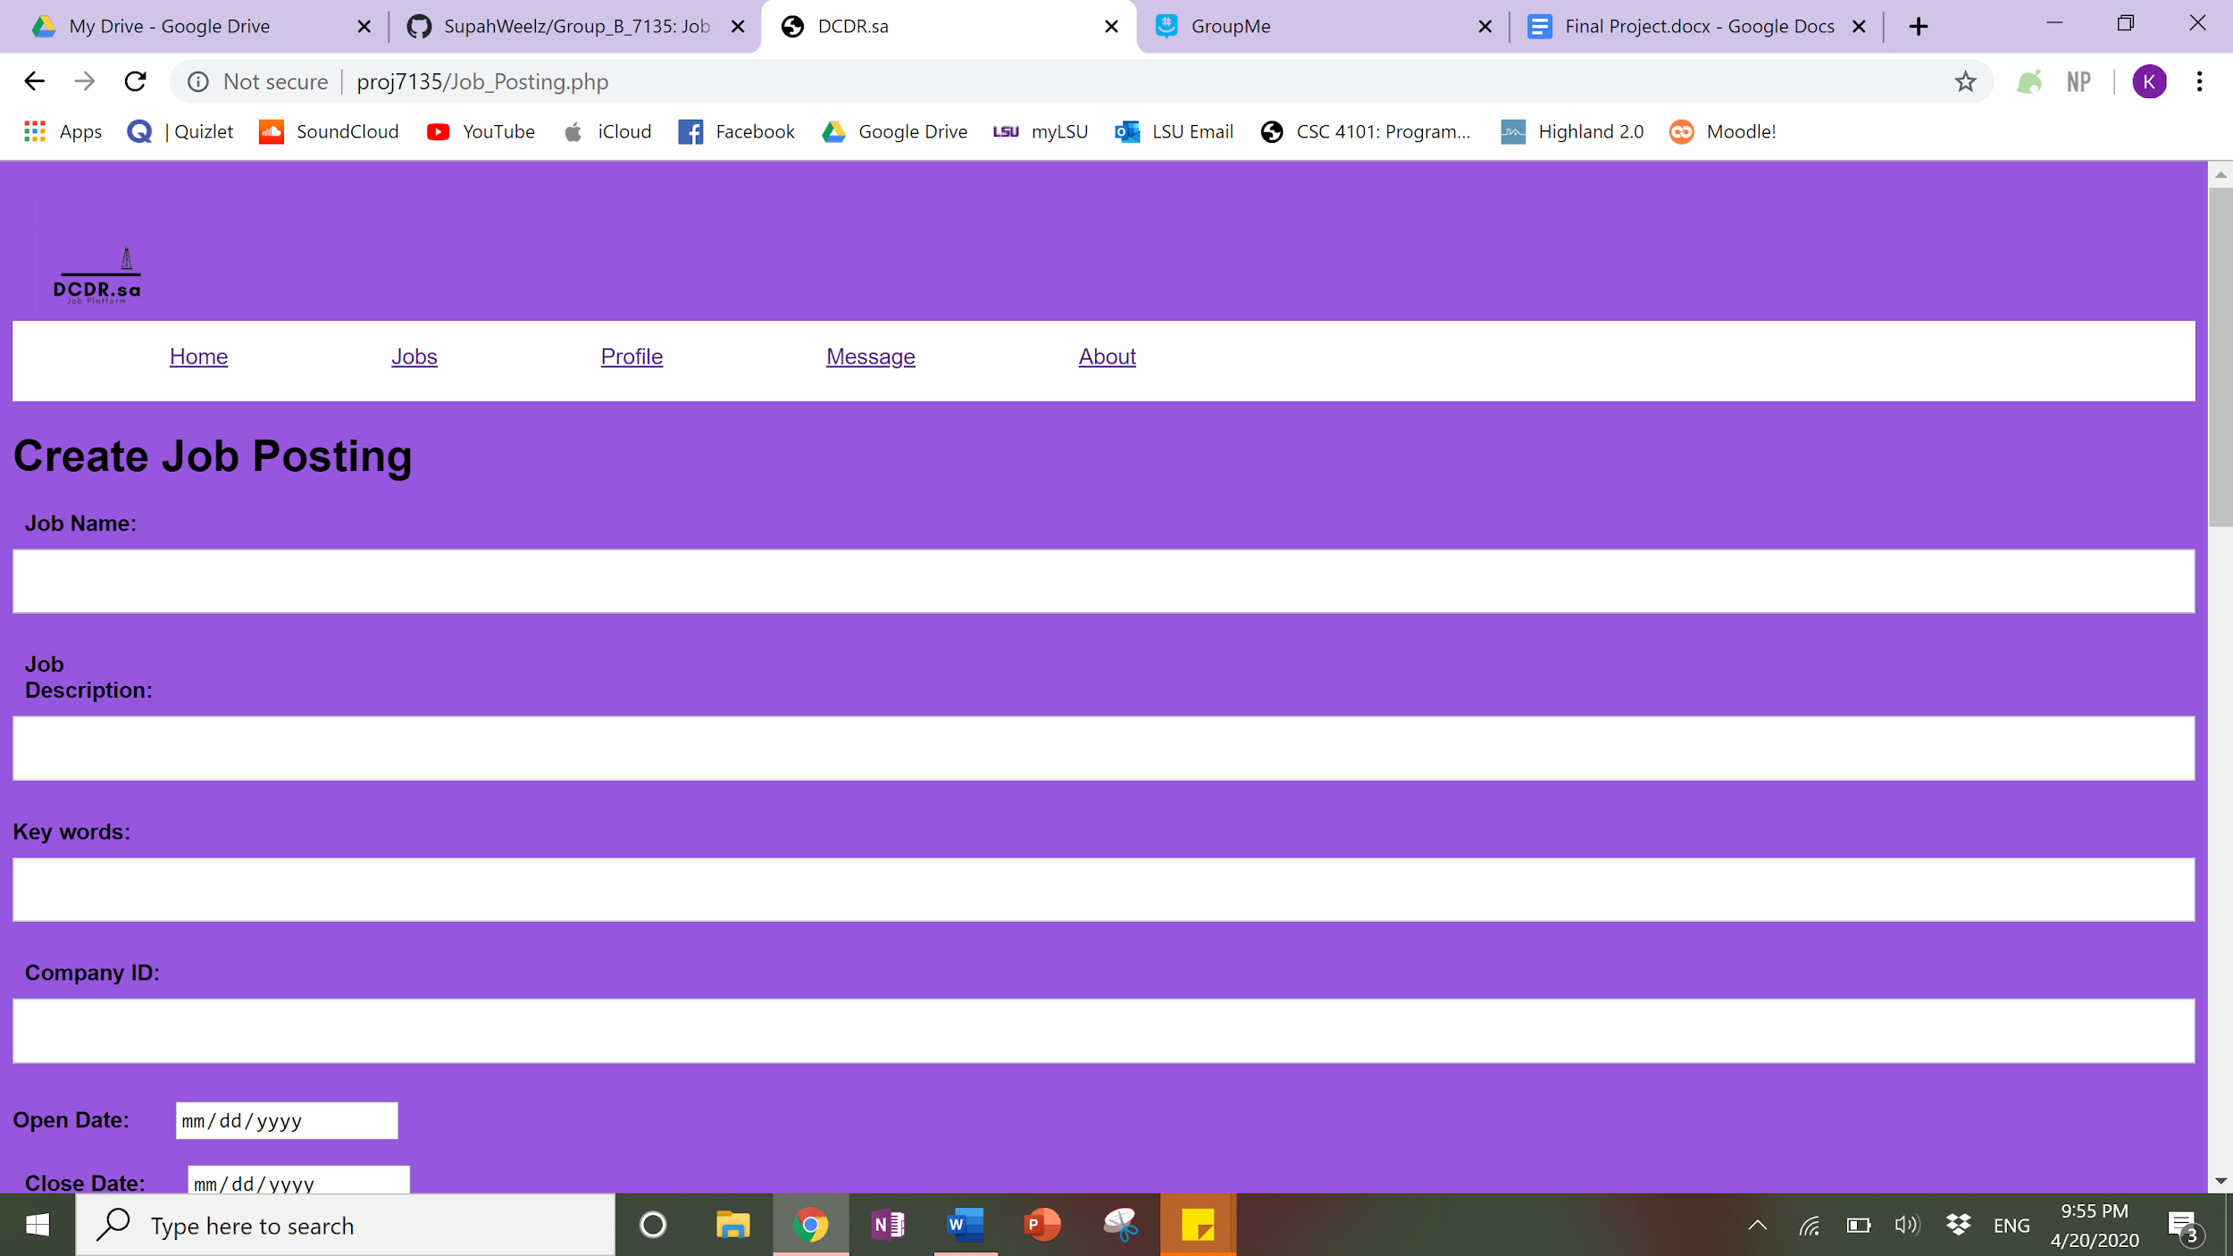

Once all of the fields have been completed and submitted the screen will prompt “Job added successfully!”

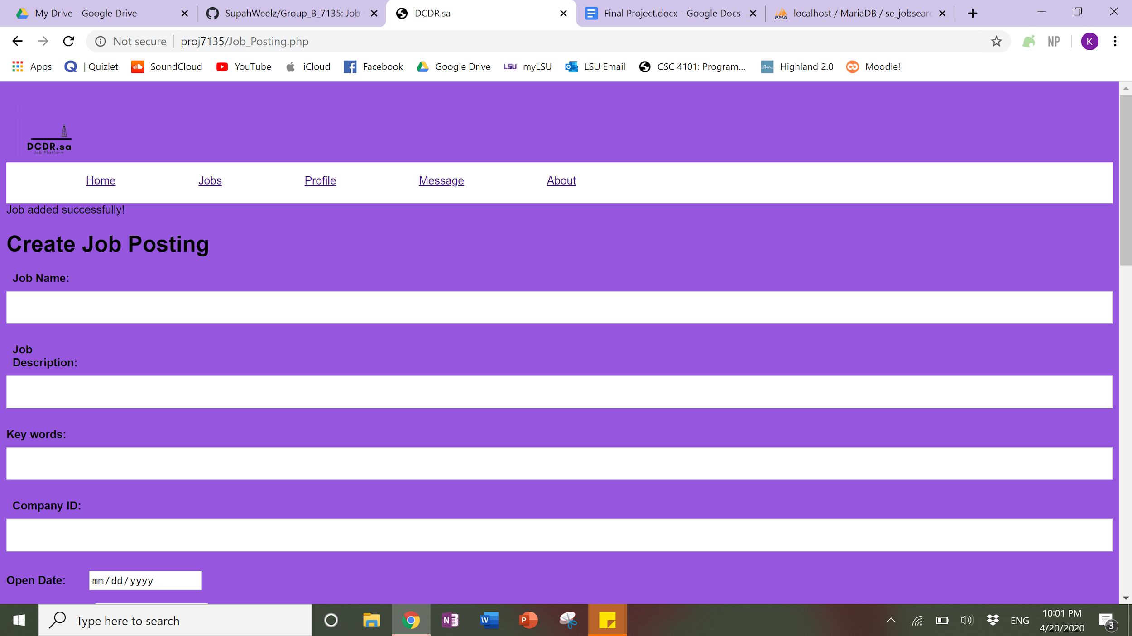

The recruiter can then view their postings on their profile.

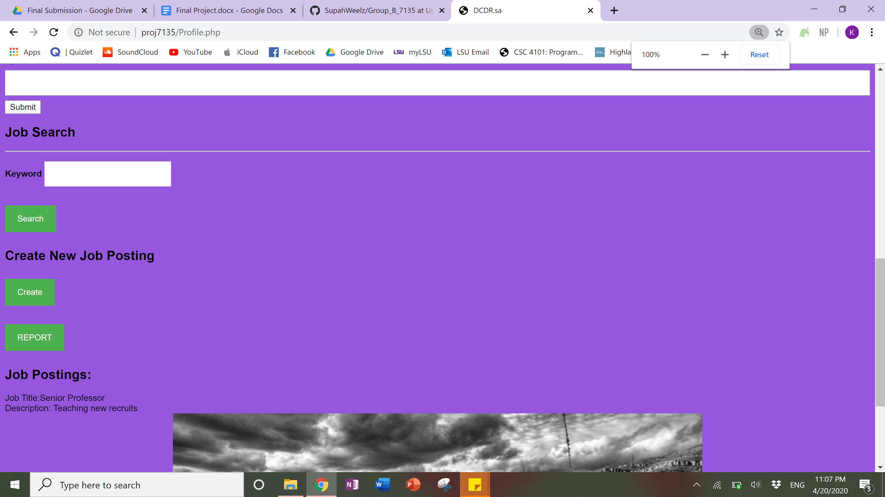

On the Recruiter page there is a button to generate the ‘monthly’ report.



Once you click the report button it will open this page which prompts for the date in order to get the report. It was also intended to allow the recruiter to remove jobs but this was not completed.

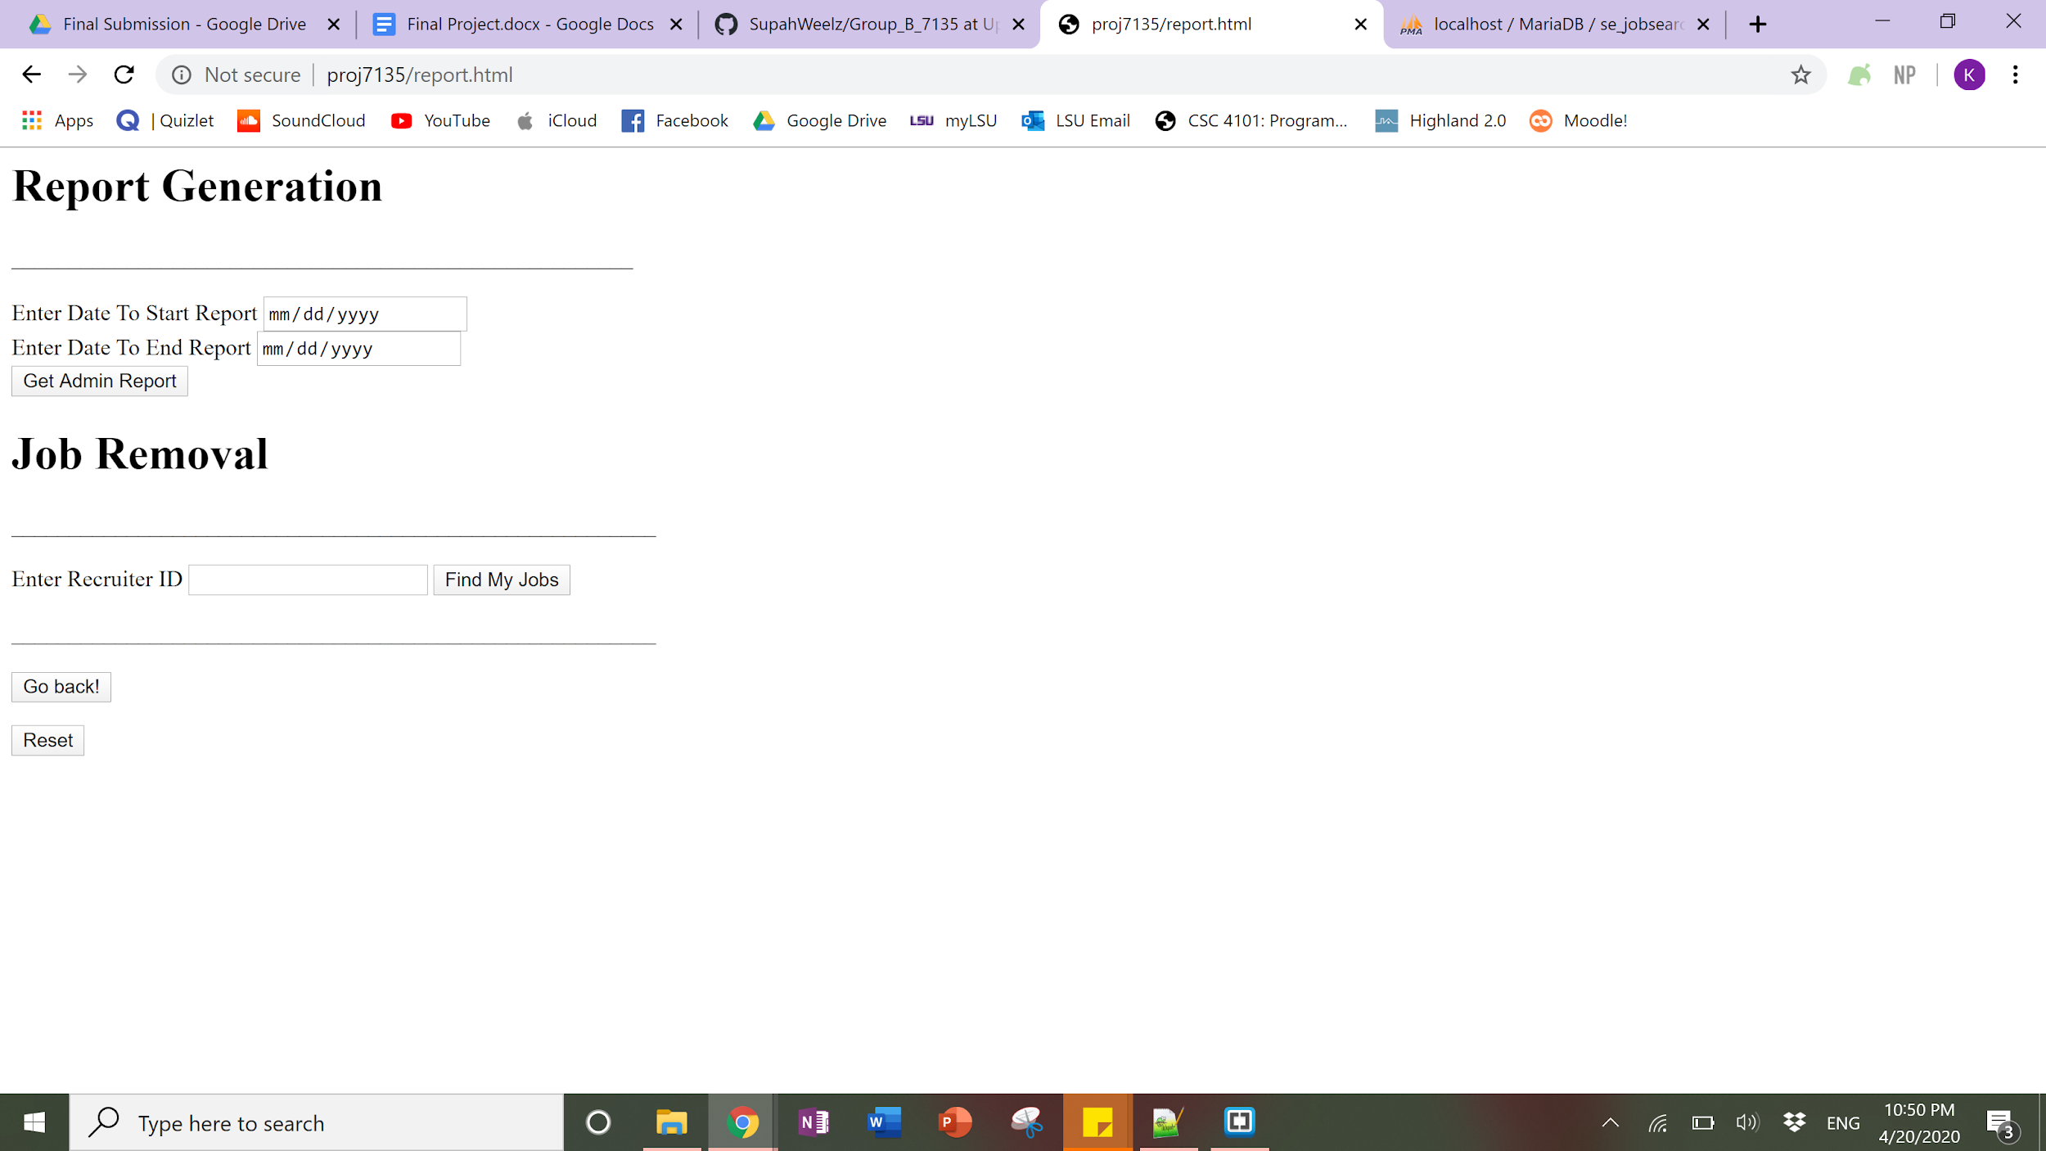

Once a user inputs their report dates and clicks the “Get Admin Report” button the report page will display, as seen below.

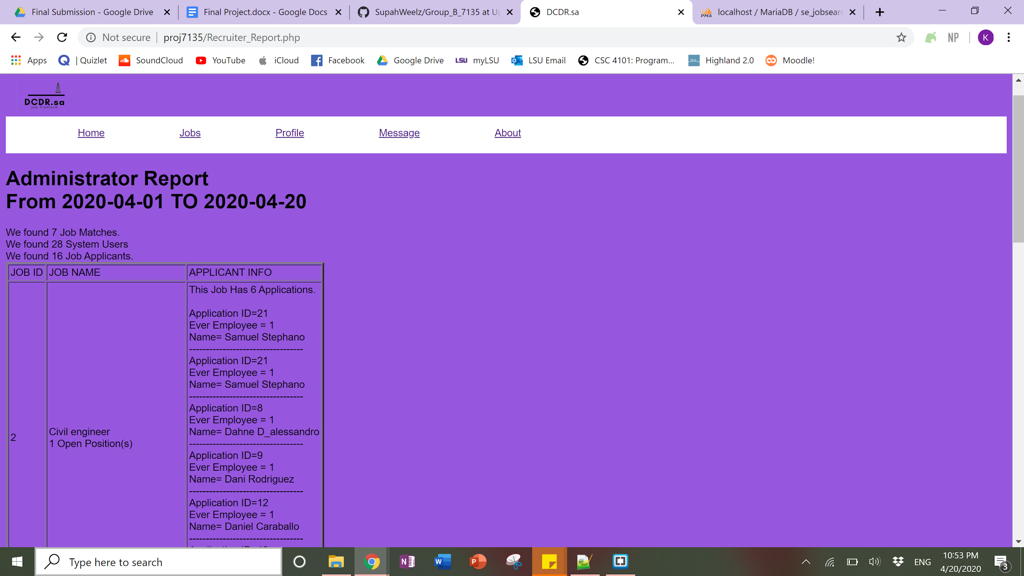

An admin user has more options to view reports such as view all employees of all companies by clicking on EmployeeListing_AllCompany.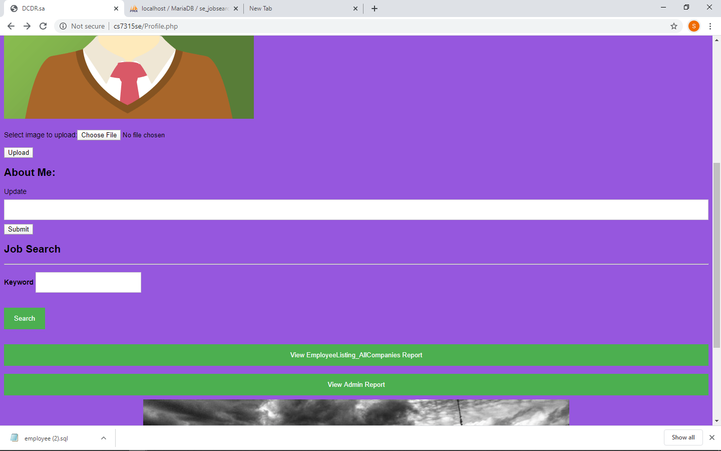And the result as follows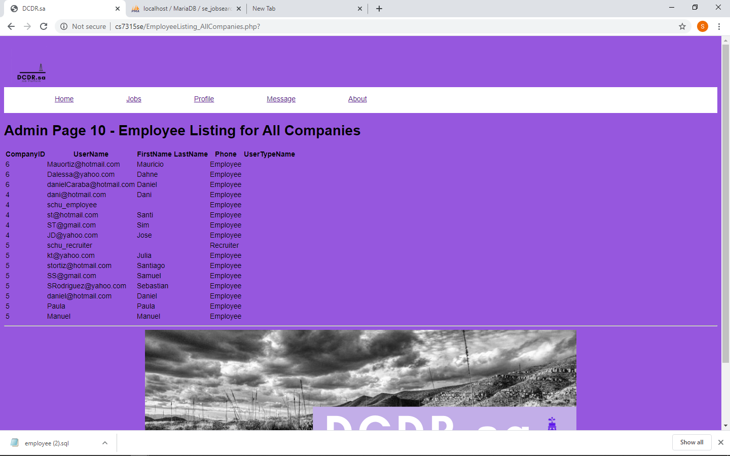

For all users, if you click “message” on the navigation bar it will pull up the chat option which is saved in the database and allows the users to interact.

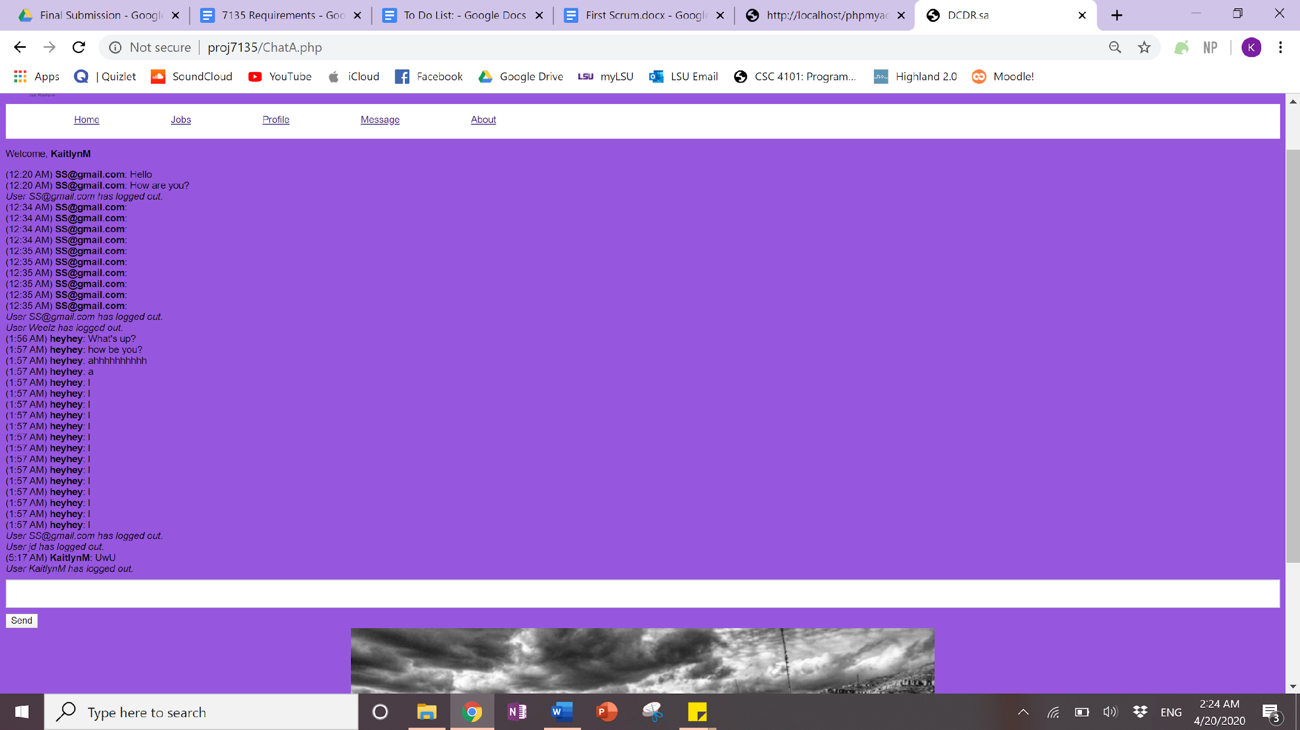

The “About Us” page accessible through the navigation bar on the top shows a short blurb about the association as well as their address and contact details.

